**Installation of Executable file:**

run the game.py file.

A window will be appeared there, Set the destination where user wants to install it.

Then click next and installation will be started, and at last click on Finish.

Go to folder where it is installed, click on application file,

Application will be opened.

Only 1 player can be controlled by the user,

Other players will be the system players.

Here is the UI layout of the game.

1st window menu:

chose the difficulty level from the selection area between Easy, Medium or Hard and select play

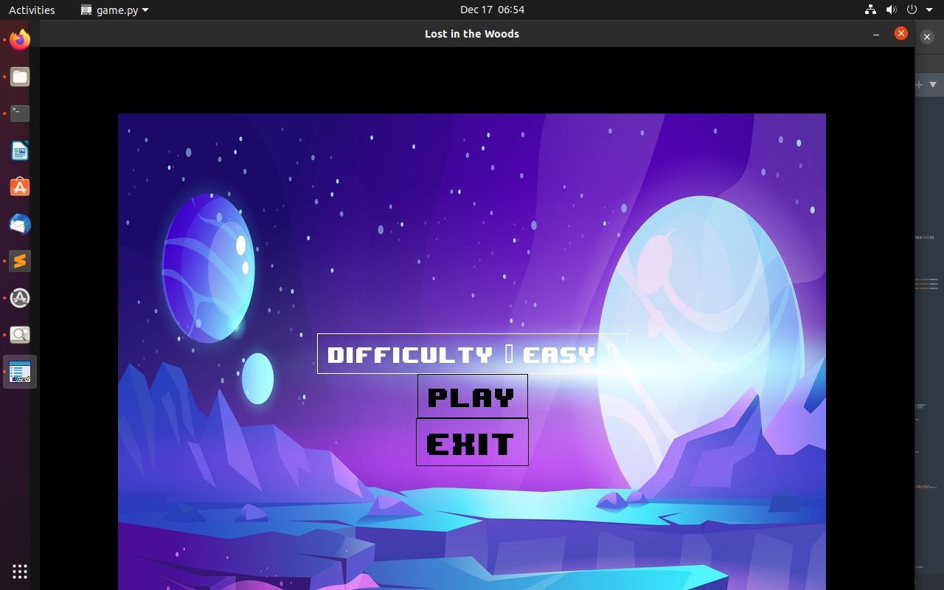2nd window menu :

In this window menu chose row column and players from the selection menu and select the start button to play the game.

Select Back to Menu button to go to the first window menu to chose difficulty level again.

Select the Scores to see the previous scores.

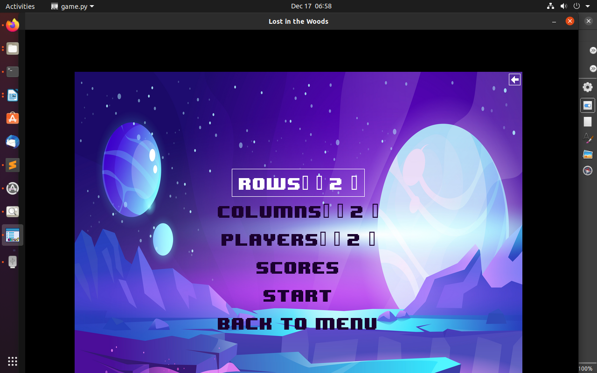

3rd window menu:

play the game with keyboard arrow keys..

